Project Design Phase-II
Data Flow Diagram & User Stories

Date | 20 February 2026
Team ID | LTVIP2026TMIDS66345
Project Name | Streamlining Ticket Assignment for Efficient Support Operations
Maximum Marks | 4 Marks

Data Flow Diagrams:
A Data Flow Diagram (DFD) is a traditional visual representation of the information flows within a system. A neat and clear DFD can depict the right amount of the system requirement graphically. It shows how data enters and leaves the system, what changes the information, and where data is stored.
Example:
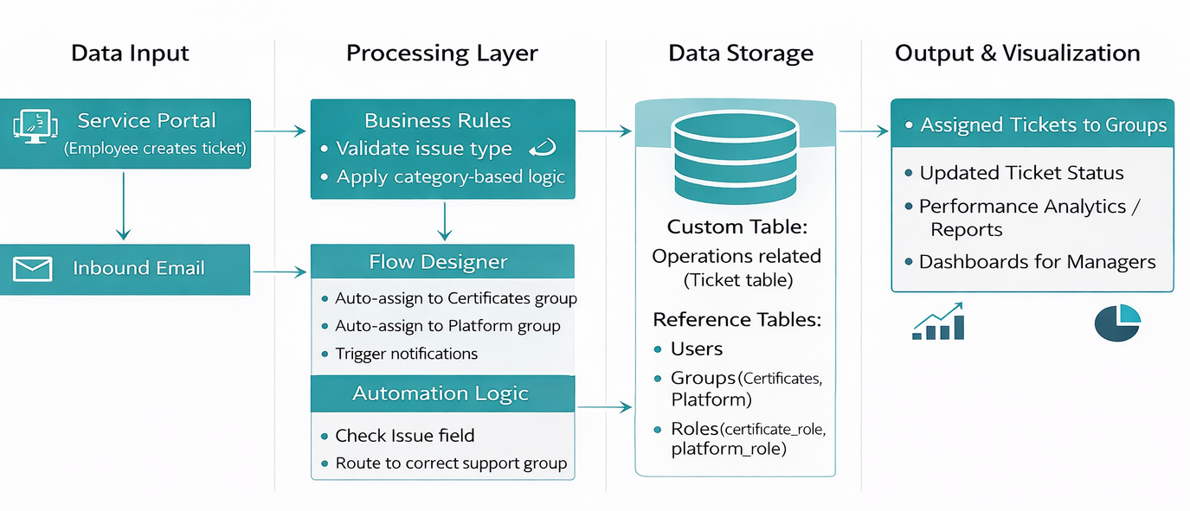
User Stories
Use the below template to list all the user stories for the product.
User Type | Functional Requirement (Epic) | User Story Number | User Story / Task | Acceptance Criteria | Priority | Release
Customer (Employee raising ticket) | Ticket Creation | USN-1 | As a user, I can create a support ticket by selecting issue type and entering description. | Ticket is successfully created in Operations related table | High | Sprint-1
Customer (Employee raising ticket) | Ticket Creation | USN-2 | As a user, I can select predefined issue categories (Login, 404 error, Certificates, User expired). | Issue field shows predefined choices and saves correctly | High | Sprint-1
Customer (Employee raising ticket) | Ticket Tracking | USN-3 | As a user, I can view the status of my submitted ticket. | User can see ticket status (Assigned, In Progress, Resolved) | High | Sprint-2
IT Support Staff (Certificate Group) | Automated Assignment | USN-4 | As a certificate support member, tickets related to certificates are automatically assigned to my group. | Tickets with “Regarding Certificates” are auto-assigned to Certificates group | High | Sprint-1
IT Support Staff (Platform Group) | Automated Assignment | USN-5 | As a platform support member, platform-related issues are automatically assigned to my group. | Tickets with login/404/user expired issues are auto-assigned to Platform group | High | Sprint-1
IT Support Staff | Ticket Resolution | USN-6 | As a support staff member, I can update ticket status and add resolution details. | Staff can edit and update ticket records successfully | High | Sprint-2
Administrator | User Management | USN-7 | As an admin, I can create users in the system. | Users are created with correct roles and login access | High | Sprint-1
Administrator | Group Management | USN-8 | As an admin, I can create and manage support groups. | Groups are created and visible in system security settings | High | Sprint-1
Administrator | Role Management | USN-9 | As an admin, I can assign roles to users and groups. | Users/groups receive proper access permissions | High | Sprint-1
Administrator | Access Control | USN-10 | As an admin, I can configure ACL rules for ticket table and fields. | Only authorized roles can read/write records | High | Sprint-2
Administrator | Workflow Automation | USN-11 | As an admin, I can configure flows in Flow Designer to automate ticket routing. | Flow triggers automatically assign tickets based on issue type | High | Sprint-1
Management | Reporting & Analytics | USN-12 | As a manager, I can view reports and dashboards on ticket performance. | Performance tables and dashboards display ticket analytics | Medium | Sprint-2

